EXPERIMENT 13

3 PHASE INDUCTION MOTOR (CAGE ROTOR)

EQUIPMENT

* Three Phase Asynchronous Cage Rotor Motor.
* Three phase variable A C Supply.
* AC and DC Voltmeter and Ammeter.
* Load Box.
* PMDC Motor.

INTRODUCTION

Squirrel cage motors are a subclass of induction motors, which harness electromagnetism to generate motion. They are so-called “squirrel cage” motors because the shape of their rotor – the inner component connected to the output shaft – looks like a cage. Two circular end caps are joined by rotor bars, which are acted upon by the electromagnetic field (EMF) generated by the stator, or the outer housing composed of laminated metal sheets and coiling of wire. The stator and the rotor are the two fundamental parts of any induction motor, and the squirrel cage is simply one method of leveraging the electromagnetic induction effect. The AC current passed through the stator creates an EMF that fluctuates with the AC frequency, which “rotates” around the rotor, inducing opposing magnetic fields in the rotor bars, thus causing motion.

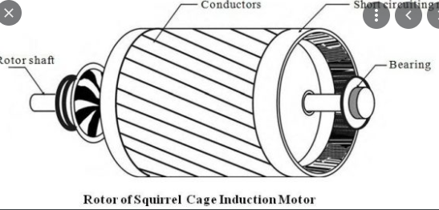

Which type of rotor is used in squirrel cage induction motor?

Up to 250 percent of the full-load torque, the starting torque is in this class of design. The pullout torque is lower than that for Class A **induction motors**. In this design the **motors** are built from double-**cage rotors**.

Which type of rotor is used in 3 phase induction motor?

There are two **types** of **induction motor rotors**: Squirrel-cage **rotor** or simply cage **rotor**. **Phase** wound or wound **rotors**.

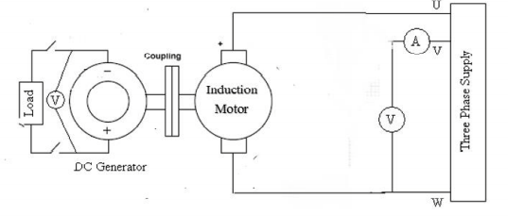

OBJECTIVE

* To study the torque speed curve of the induction motor (Cage Rotor).

APPLICATION

**The squirrel cage induction motors are used in residential as well as industrial applications especially where the speed control of motors is not needed such as:**

* Pumps and submersible.
* Pressing machine.
* Lathe machine.
* Grinding machine.
* Conveyor.
* Flour mills.
* Compressor.
* In driving air compressors, conveyors, reciprocating pumps, crushers, mixers, large refrigerating machines, etc.
* Punch presses, shears, bulldozers, small hoists, etc.
* And other low mechanical power **applications**.

PROCEDURE

1. According to the given diagram in Figure 13.1 connect the different electrical wires.

2. Supply the Three phase voltage to the 3 Phase cage asynchronous Motor.

3. In order to take necessary precautions, connect a relay and thermal connector between the two.

4. The 3 Phase cage Asynchronous motor is coupled to the DC motor that acts as a generator.

5. Connect the generator to the Torque Power Measurement gauge.

6. The load is connected to the Generator through an ammeter.

7. Switch on the 3 Phase power supply and measure the Torque, Speed, Power and current at no load.

8. Now increase the load by a single step and note down the readings in the given table.

9. You can measure the speed through a tachometer.

10. Find the torque using formula of P = 𝜁 ∗ 𝜔. Keep in mind that w is the speed in radians per second.

11. Plot the graph of Torque vs. Speed from the data recorded in the Table – I.

ISSUE

Didn’t perform this experiment practically.

CONCLUSION

To conclude this experiment I would end up it by saying that its working is based on the **principle** of electromagnetism. When the stator winding is supplied with a **three**-**phase AC**, it produces a rotating magnetic field (RMF) which has a speed called synchronous speed. This RMF causes voltage induced in the rotor bars.

POST LAB QUESTIONS

1. Draw a graph between Torque and Speed from the above noted values.

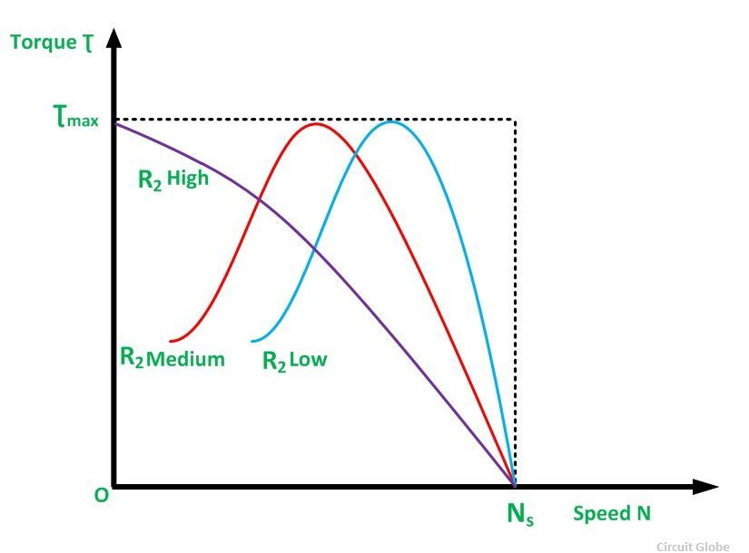

2. How much torque can an induction motor supply at the starting conditions?

**Starting torque** is the **torque** produced by **induction motor** when it starts. We know that at the **start** the rotor speed, N is zero

1. How does the speed of an induction motor vary as the load gets changed? Explain it with respect to the graph you plotted.

As load gets increase at max torque the speed is high by the time speed gets decrease. As load value decreases in early stages its speed first increases and approaching to torque (max) it then move towards declining.

4. What is the difference between cage rotor and wound rotor?

The **motor** whose **rotor** is **wound** type such type of **motor** is called slip ring induction **motor**, whereas the squirrel **cage motor**, has a squirrel **cage** type **rotor**. The **rotor** of the slip ring **motor** has a cylindrical core with parallel slots, and each slot consists each bar. The slip ring **motor** is also called phase **wound rotor**.

The **rotor** windings **of** a **wound**-**rotor motor** circuit are not short-circuited while starting; whereas the **rotor** windings **of a squirrel**-**cage induction motor** are always short-circuited. ... A **wound**-**rotor**? Is designed to provide **rotor** circuit resistance during startup and remove that resistance when the **motor** is up to speed.